MINISTRY OF AGRICULTURE

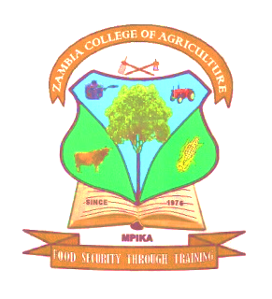

ZAMBIA COLLEGE OF AGRICULTURE MPIKA
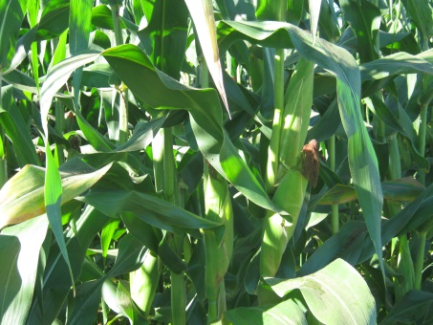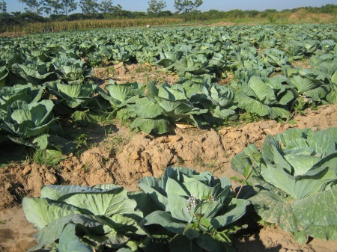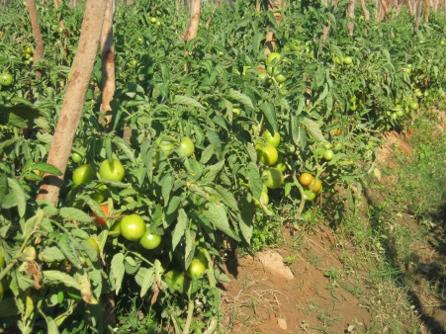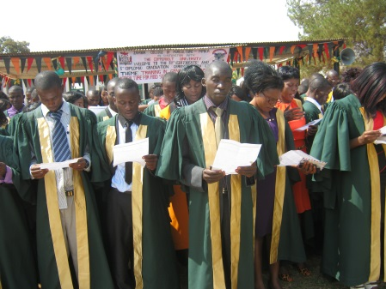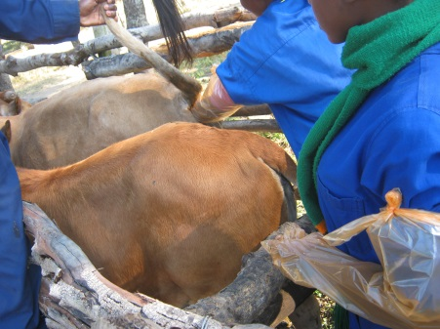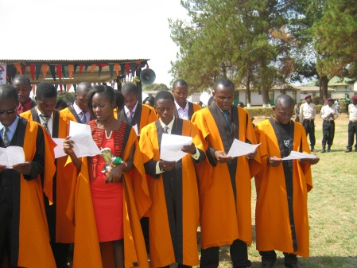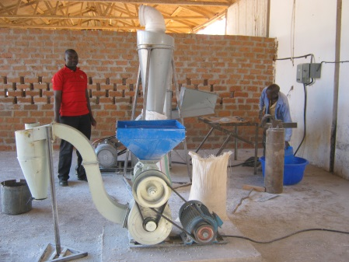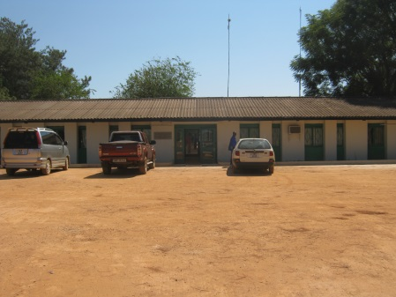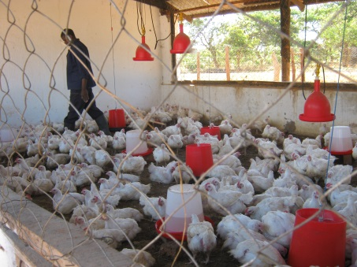

STRATEGIC PLAN
2018 – 2021

September 2018

Table of Contents
ACRONYMS ii
1.0 INTRODUCTION 1
1.1 Background 1
1.2 The Climatic Conditions 2
1.3 Strengths, Weaknesses, Opportunities and Threats Analysis 2
1.4 Vision 3
1.5 Mission 3
1.6 Objectives 3
1.6.1 Specific/Strategic Objectives 3
2.0 IMPLEMETATION STRATEGIES 4
2.1 SO1: To effectively provide knowledge and skills to 600 of both certificate and diploma students by December 2021 4
2.2 SO2: To increase the capacity of the College to provide quality training to clientele in the most efficient way by December 2021 5
2.3 SO3: To carry out one curriculum review of certificate and one for diploma programmes to ensure conformity to the needs of industry by December 2021 5
2.4 SO4: To expand all production units by 25% in order to increase income generation by December 2021 6
2.5 SO5: To expand college infrastructure by 10% to meet the needs of the expanded training programmes by December 2021 8
2.6 SO6: To offer one other diploma and one degree programmes to meet the needs of the general public by December 2021 8
2.7 SO7: To carry out research in areas of sustainable agriculture and other related areas of agricultural activities both in the short term and long term 9
3.0 SCHEDULE OF ACTIVITIES AND INDICATIVE BUDGET 10
4.0 ZCA STAKEHOLDER ANALYSIS 11
5.0 PRE CONDITIONS 11
6.0 ORGANIZATIONAL STRUCTURE 11
7.0 COURSES OFFERED BY THE COLLEGE 15
8.0 THE STRATEGIC BUDGETING PROCESS 15
9.0 REPORTING, MONITORING AND EVALUATION 15
9.1 Reporting 15
9.2 Monitoring 16
9.3 Evaluation 16

ACRONYMS
CBU Copperbelt University
CGA Certificate in General Agriculture
DAE Diploma in Agricultural Education
DSA Diploma in Sustainable Agriculture
HIV/AIDS Human Immunodeficiency Virus/Acquired Immuno-Deficiency Syndrome
HRA Human Resources and Administration
MoA Ministry of Agriculture
NGO Non-Governmental Organization
TAZARA Tanzania Zambia Railway Authority
UNZA University of Zambia
ZCA Zambia College of Agriculture

INTRODUCTION
This document outlines the Strategic Plan of the Zambia College of Agriculture (ZCA) – Mpika covering the period 2018 to 2021. The Zambia College of Agriculture – Mpika is an Agricultural Training Institution that falls directly under the Ministry of Agriculture (MoA), under the supervision of the Department of Human Resource and Administration (HRA). The College is situated in Muchinga Province, 660 Km North of Lusaka and 20 Km North of Mpika Town along the Great North Road. The Zambia College of Agriculture – Mpika is situated on a farm with total land area of 2,764 hectares.
The College offers a 2 year certificate programme in General Agriculture, a 3 year diploma programme in Sustainable Agriculture and a 3 year diploma programme in Agricultural Education, all the programmes are also offered on Distance Learning mode taking slightly over two and three years, respectively.
Upon completion of the courses, the certificate graduates are employed as frontline staff in the extension service of the Ministry of Agriculture and outside, while the diploma graduates occupy middle level managerial and supervisory positions in the agriculture and related sectors. The Agricultural Education graduates become teachers of Agriculture Science subject in secondary schools.

Background
The Zambia College of Agriculture – Mpika was established in 1976 by an act of Parliament to train human resources who would be employed as extension workers upon graduation in the Ministry of Agriculture.
The College has three lecture theatres, five classrooms, four hostels, dining facilities, three laboratories and a library, as well as qualified and motivated trainers to carry out the training of school and non-school leavers. The hostels capacity is about 500 bed space. The trainees undergo practical hands-on training throughout their study period at the college. This is made possible by the availability of a farm, which serves as live laboratory for the students. The farm has mixed herd of beef animals totalling around 100, 60 animals in the piggery unit, a poultry unit rearing about 1000 each for both layers and broilers and 33 animals in the goat unit. In crops, the farm has maize, vegetables including cabbage, Chinese cabbage, tomato, onion, eggplant, water melon and impwa, and also fruit trees including guavas and citrus.
From inception ZCA has had no major developmental partner to assist rehabilitate the infrastructure; it has always relied on the government recurrent and capital funding for infrastructure development. This dependence on government funding has led to poor state of the entire infrastructure including the classrooms, laboratories, production unit buildings, staff housing units and road infrastructure, as government has a lot of needy areas that require funding. However, a 230 sitter capacity lecture theatre was constructed in 2012 and another of the same capacity in 2016 with funds from the government.

The Climatic Conditions
The College falls in Agro-ecological Region III, which is a high rainfall area. Average annual rainfall exceeds 1,200 mm. The rainfall is uni-modal and the rain season extends between October and May. In recent times the highest recorded temperature was 37ºC. In July night temperatures dropped down to 8ºC. It lies in the tropical region at latitude 12º S and longitude 33.3º E and at about 1,400 metres above sea level.

Strengths, Weaknesses, Opportunities and Threats Analysis
As ZCA embarks on the strategic developmental plan, it is important to take note of the environment in which the activities are going to be undertaken. Therefore, the SWOT analysis becomes important.

Strengths:
- Human resource, well qualified young and energetic personnel
- Security, there is a Police Post within the college
- Electricity is available
- Accessibility, ZCA is connected to all-weather roads both from Lusaka in the south and northern towns such as Kasama and Chinsali
- Abundant land for livestock and crop production
- Initial training infrastructure in place
- Water system, plenty of underground and surface water available
- Adequate staff accommodation
- Primary school available
- Rural Health Centre available

Weaknesses:
- Dilapidated infrastructure
- Poorly equipped laboratories, workshops and library
- Inadequate numbers of personnel
- Inadequate transport to undertake training activities
- Inadequate venture capital
- Inadequate training materials and equipment

Opportunities
- Availability of demand for the training programmes being offered
- The only public college in the northern part of the country offering agricultural courses
- Availability of a mechanical workshop at TAZARA
- The liberalization of the economy offers opportunities for diverse livestock and crop production
- Large numbers of school leavers and existence of farmer groups within the district gives opportunities for increased training demand
- Large size of land at the institution, which is not fully utilized
- Favourable climatic conditions
- Mpika is an upcoming town in Zambia
- The establishment of new industries in the district such as ZamPalm

Threats:
- Inadequate employment opportunities for agriculture graduates in the country
- High staff turnover due to transfers and search for greener pastures
- Competition from other institutions offering related courses
- Competition in production of quality agriculture produce
- Inadequate financial resources
- Impact of HIV/AIDS and malaria on human resources
- Long distance to major towns for procurement of goods and services

Vision
We aspire by 2021 to be a College with a capacity to provide opportunities for training that is affordable and sustainable at certificate, diploma and degree levels in agriculture and related disciplines.
Therefore, our Vision is “To be a centre of excellence in agricultural training and research”

Mission
Our Mission is ‘To provide suitably and adequately trained human resource in agriculture and related disciplines in order to meet the labour demands of the agricultural sector’

Objectives
This mission statement is fulfilled by a number of objectives, and these are:
- To provide quality practical training opportunities to students
- To provide opportunity for the students to demonstrate competence and understanding through research projects
- To manage and maintain a viable and self-sustaining college farm for students’ practicals
- To maintain self-sustaining income generating ventures which are intended to supplement government funding.

Specific/Strategic Objectives
In order for ZCA to realize its overall mandate of training school leavers, non-school leavers and farmers and conduct research, and to monitor the performance of the College during this Strategic Plan period, specific/strategic objectives that are measurable and attainable have been formulated. These are as presented below:
- To effectively provide knowledge and skills to 600 of both certificate and diploma students by December 2021.
- To increase the capacity of the College to provide quality training to clientele in the most cost efficient way by December 2021.
- To carry out one curriculum review of both the Certificate and Diploma programmes to ensure they are in conformity with the needs of industry by December 2021.
- To expand all production units by 25% in order to increase income generation by December 2021.
- To expand college infrastructure by 10% to meet the needs of the expanded training programmes by December 2021.
- To offer one other diploma and one degree programmes to meet the needs of the general public by December 2021.

IMPLEMETATION STRATEGIES

SO1: To effectively provide knowledge and skills to 600 of both certificate and diploma students by December 2021
In order to increase the productivity of the Agriculture sector, the competently trained human resource is required. Zambia College of Agriculture – Mpika will continue to provide knowledge, skills and attitude change to an average of 200 school and non-school leavers per annum in General and Sustainable Agriculture and Agricultural Education at certificate and diploma levels. Furthermore, the College will endeavour to provide knowledge and skills to 60 Community and Cooperative members as the need for training will dictate in this area during the planning period. Because of the nature of the sector, the College will ensure that the training is as practical as possible. This will be done by utilizing the students in the production units of the College and also the facilities in the commercial farms within the Province. In addition to its staff the College will draw qualified part time and specialised staff from the field to strengthen the delivery of training to the clientele.

The main activities under this objective will include:
- Advertising and recruitment of students to pursue training in the three programs
- Development of teaching materials
- Mainstreaming gender in all training programmes
- Teach students theory and practical skills in General and Sustainable Agriculture and Agricultural Education
- Attaching students to various agricultural related ventures so as to avail them the first-hand experience of the agricultural environment
- Attaching students to various schools for Teaching Practice
- Improving internet connectivity to the College
- Improving the boarding and lodging facilities for course participants
- Providing sporting activities to students

Output Indicators:
- Engendered training materials in all modules prepared/acquired and in place
- Recruitment advertisements aired and 200 new students recruited annually
- Adequate classroom and laboratory spaces provided to all students
- Adequate board and lodging facilities available to course participants
- Reports on the students field attachment and teaching practice available

SO2: To increase the capacity of the College to provide quality training to clientele in the most efficient way by December 2021
In order for the College to carry out its main objective of equipping school and non-school leavers with General and Sustainable Agriculture and Agricultural Education knowledge and skills, the College will endeavour to strengthen the capacity of staff to enable them impart effective training and also embark on rehabilitation of infrastructure.
The upgrading of staff skills will be both formal and informal. In this regard, the college plans to send all the training staff at different times for training of trainers’ courses where ever such courses are provided either locally or abroad. The college also intends to introduce within the curricula the provision of entrepreneurship skills training. Additionally, members of staff will have access to facilities that will equip them with computer skills for them to be able to efficiently and effectively execute their tasks. Resources permitting, the College will continue to purchase computers for the members of staff offices and students so as to increase access to these facilities. In strengthening the staff skills, the College will continue to lobby the Ministry of Agriculture to recruit new teaching staff to augment the present number and cope with the increasing number of students.
The main activities under this objective will include:
- Recruitment of teaching staff through the Ministry headquarters
- Training of staff both locally and abroad according to the training plan of the College
- Renovation of hostels, labs, library and classrooms
- Renovation of sporting facilities
- Furnishing of hostels, labs, library and classrooms including internet connectivity
- Procurement of library books/materials and laboratory equipment
- Renovation of staff houses.
- Renovation of water reticulation system for domestic use

Output indicators:
- Students’ infrastructure and furniture in good working condition.
- Library well stocked with modern books and journals
- Pedagogical skills for staff upgraded
- Adequate sports facilities for both staff and students in place
- Staff housing in good condition
- 24 hours safe water supply to all areas of the College

SO3: To carry out one curriculum review of certificate and one for diploma programmes to ensure conformity to the needs of industry by December 2021
Since inception in 1976 the college was offering a 2 year certificate course to would be extension officers. This programme has been a success so that to-date over 4000 graduates have been produced. In 2005 the College, realizing that the demand for the 2 year program was overwhelming, conducted needs assessment to determine whether or not new training programmes would be welcome. With the guidance of the Copperbelt University (CBU), Ministry of Agriculture and other stakeholders, a new diploma curriculum was developed. The birth of the 3 year Diploma in Sustainable Agriculture programme in 2007 was a result of this activity. The third programme was launched in 2017, the Diploma in Agricultural Education, which produces teachers of Agriculture Science subject for secondary schools, similarly, under the CBU. The other one is the Diploma in Food Technology, whose curriculum is still being developed.
The curricula for current programmes were reviewed more than three years ago. In this strategic period the College will, therefore, embark on a vigorous review of the present curricula so that it meets the demands of the fast developing agriculture industry in the country and the region. To do this, the College will administer a needs assessment questionnaire to determine the needs of the market as regards our training and organize curriculum review workshops with various stakeholders to develop the training manuals for the college.
As the curricula is being reviewed, ZCA will endeavour to incorporate into the new syllabi entrepreneurship skills training to all its trainees so that after graduation they are able to start their own small-scale production units. The College will also incorporate aspects of apiculture and aquaculture in its current syllabi. This will increase the demand for the training programmes being offered even further and create more employment opportunities for graduates.
The main activities under this objective will include:
- Carrying out needs assessment
- Review and Development of detailed syllabi for certificate and diploma programmes
- Development of training manuals
- Continuous review of curricula to meet the needs of the agriculture sector
Output indicators:
- Needs assessment report available
- Reviewed course syllabi available
- Reviewed course manuals available

SO4: To expand all production units by 25% in order to increase income generation by December 2021
The total land area for Zambia College of Agriculture - Mpika is about 2,764 hectares. Out of this a total of 600 ha is actively used for cropping and livestock use. The rest of the land is not being used, but can be used for many developmental programmes. Currently the college has adequate buildings to manage a commercial farm and the following enterprises are running: poultry, piggery, beef herd, goat unit, orchard and garden. The produce from these enterprises is sold to the surrounding community. The students are deeply involved in the management of these enterprises.
During this strategic plan period, the target is to expand and put most of the infrastructure to full use. The following enterprises are to be expanded: The poultry unit will include rearing of broilers, layers, quails, local chickens, rabbits and guinea fowls. The piggery unit will expand to a 30 sow unit. The Dairy herd will be brought in with 10 milking cows and expand the beef herd to 100 breeding cows. The vegetable garden will be producing assorted vegetables throughout the year. To cater for the feed requirement for the expanded livestock numbers the rain-fed field crops will be expanded and pastures will be introduced. Annually a minimum of 40 ha of maize will be grown for humans and livestock. We envisage that with these production units in full swing the college can sustain most of its activities and the quest for the college to include entrepreneurship skills in the syllabi will be easily achieved since students will be heavily involved in these production ventures.
College management is convinced that the above plans are attainable because the College has adequate land, surface water, well trained and dedicated staff, and above all conducive environmental conditions. There are also some indications that some donor agencies might come in to help face-lift the existing infrastructure. Once the production units are in full swing, the community stands to benefit in the sense that they will then have ready supply of farm produce, and employment and training opportunities will be available.
During the same strategic period, the College also plans to open up an outlet in Mpika Township for farm produce including; mealie meal, milk, chickens, beef, eggs, stock feed and other products. This will be made possible with the increase in production of the various products mentioned above. There are also plans to have a hatchery at the farm to be hatching chickens, quails and other birds. This will increase population of birds in the poultry and justify the cage rearing method for layers in order to produce more eggs.

The main activities under this objective will include:
- Continuous renovation of livestock pens
- Construction of livestock paddocks
- Implementation of sound livestock breeding and husbandry practices
- Procurement of stock feed and other inputs
- Restocking of the breeding stock
- Expanded production of field crops
- Sales of livestock and livestock products
- Growing of pasture and fodder crops
- Water reticulation for vegetable garden – more efficient irrigation system (drip and sprinkler irrigation), and water for livestock use
- Acquisition of a hatchery and cages for poultry production

Output indicators:
- Well-constructed pens - fully stocked with birds and other animals
- Vegetable garden fully functional
- Increased calving rate to 80% and reduced calf mortality to less than 5% for the beef herd
- Students fully involved into the production ventures
- Adequate livestock feeds produced by the college
- Adequate availability of livestock and livestock products for sale
- Adequate water supply for crops and livestock
- Hatchery in place and being used

SO5: To expand college infrastructure by 10% to meet the needs of the expanded training programmes by December 2021
Current infrastructure include two 230-sitter lecture theatres, an 80-siiter lecture theatre, five 40-sitter classrooms, a 25-sitter science laboratory, a 25 sitter home science laboratory, a 40-sitter computer laboratory and 74-sitter library. As can be seen from the foregoing, infrastructure capacity for student use is quite small. To implement the above ambitious training programmes, there is need for more infrastructure to be constructed. During this strategic period, the College will construct two blocks of two science laboratories each and a 150 bed space hostel. The library and the computer laboratory will also be expanded to increase their capacities to 150 and 80 respectively.
The main activities under this objective will include:
- Construction of 2 x 2 laboratory blocks
- Construction of 150 bed space hostel
- Expansion of the library
- Expansion of computer laboratory
- Furnishing of all the constructed infrastructure
- Supply internet connectivity to the expanded library
Output indicators:
- 2 x 2 laboratory blocks constructed and furnished
- 150 bed space hostel constructed and furnished
- Library expanded, furnished and internet connected
- Computer lab expanded and furnished with internet connectivity

SO6: To offer one other diploma and one degree programmes to meet the needs of the general public by December 2021
Currently the College offers three programmes, Certificate in General Agriculture, Diploma in Sustainable Agriculture and Diploma in Agricultural Education. Diploma in Food Technology will be launched as soon as it becomes ready. There are some indications that demand for Diploma in Wildlife Management and Degree in Sustainable Agriculture programmes exist. Thus, during this strategic plan period, the College aims to start offering the degree programme, while developing the other one and others that can be done within the College’s capacity.
The College will also endeavour to conduct short-term courses for beef, diary, poultry, feed formulation, fish farming, beekeeping, pig farming and catering. These courses will be intensified during the period of this strategic plan so as to meet the needs of a wider clientele.
The main activities under this objective will include:
- Initiation of the new diploma and degree programs
- Carry out outreach programmes
- Development of detailed syllabi for the diploma and degree programmes
- Development of training manuals
- Mainstreaming gender in all the training programmes
- Recruitment of students for the new programmes
- Continuous review of curricula to meet the needs of industry
- Development of course materials for various short courses
- Conducting tailor-made and demand-driven short term courses
Output indicators:
- Students for other diploma and degree courses recruited
- Other diploma courses materials developed which are gender sensitive
- Degree course materials developed which are gender sensitive
- Other diploma courses and degree course running
- Training materials for short courses developed and courses conducted

SO7: To carry out research in areas of sustainable agriculture and other related areas of agricultural activities both in the short term and long term
The Zambia College of Agriculture set up a research center in 2019. This was in response to the government’s call for more research to be undertaken by academic and other similar institutions. It is in view of this that during this strategic plan period, the college aims to complete equipping the ZCA Research Centre to a fully-fledged modern research centre to undertake cutting edge research in agriculture in order to provide the policy makers, stakeholders and the farming community with latest findings in agriculture to enhance their productivity for both national and household food security.
To this end, the College will endeavor to conduct research in beef, dairy, poultry, pig production, goat and sheep production, feed formulation, fisheries and aquaculture, beekeeping and similar non-wood forestry research, agro-forestry systems and fruit production as well as crop and vegetable production. Additionally, the College, through the Research Center intends to commence research in farm structures and post-harvest techniques.
The main activities under this objective will include:
- Development of a long term and short term research agenda
- To initiate research relevant to the government policy for enhanced agricultural production for food security
- Carry out consultancy activities to provide solutions relevant to current agricultural activities by farmers nationwide
- Initiate a journal to enhance dissemination of information on research findings
- Fully equip the research center offices
- Initiate collaborative research activities with other research bodies/partners
- Develop storage facilities and documentation center for all research related materials

Output indicators:
- Research center fully equipped with modern research equipment
- Research agenda fully published and operational
- Partnerships in research set up with relevant bodies

SCHEDULE OF ACTIVITIES AND INDICATIVE BUDGET

Table 1: Schedule of Activities
No | Strategic Objective | 2018 | 2019 | 2020 | 2021
SO 1 | Providing knowledge and skills to course participants | xx | xx | xx | Xx
SO 2 | Increasing capacity of the College | xx | xx | xx | Xx
SO 3 | Curriculum review and development | xx | xx
SO 4 | Expansion of the production units | xx | xx | xx | xx
SO 5 | Infrastructure development | xx | xx | xx | xx
SO 6 | Commencement of other diploma and the degree programmes |  | xx |  | xx
SO 7 | Conduct of research |  | xx | xx | xx
“SO”= Strategic Objective

Table 2: Indicative Budget (Zambian Kwacha)
No | Strategic Objective | 2018 | 2019 | 2020 | 2021
SO 1 | Providing knowledge and skills to course participants | 1,500,000 | 1,800,000 | 2,100.000 | 2,500,000
SO 2 | Strengthening capacity of the College | 2,000,000 | 3,000,000 | 2,400,000 | 3,000,000
SO 3 | Curriculum review and development | 120,000 | 250,000
SO 4 | Expansion of the production units | 1,200,000 | 1,500,000 | 2,000,000 | 3,000,000
SO 5 | Infrastructure development | 2,000,000 | 3,000,000 | 4,000,000 | 4,000,000
SO 6 | Commencement of other diploma and the degree programmes |  | 1,500,000 |  | 3,000,000
SO 7 | Conduct of research |  | 75,000 | 250,000 | 250,000
 | Total per year | 6,820,000 | 11,125,000 | 8,652,100 | 15,750,000

ZCA STAKEHOLDER ANALYSIS
The categories of organizations listed below have been identified to have an interest in the programmes ZCA is conducting currently and their expectations are, therefore, to be addressed during this strategic plan period.

Table 3: Zambia College of Agriculture Stakeholder Analysis
No. | Stakeholder | Expectation
1 | The Community and Farmers | Updated knowledge and skills
2 | Copperbelt University | Quality and high standard of training, timely training programmes, quality staff, networking
3 | Employers | Competent and practical graduates
4 | MoA | Quality training, self-sustainability, practical training, no politics
5 | Sponsors | Quality training, timely training programmes, economical tuition fees
6 | Competitors | Networking, quality training, fair competition
7 | NGOs | Partnership, civil education and training
8 | Local authority | Quality training, networking and land security
9 | Royal Establishment | Land security
10 | UNZA | Partnership, networking, quality training
11 | Students | Quality training, employment, affordable fees

PRE CONDITIONS
For the strategic objectives to be implemented and carried out successfully, the following conditions upon which the implementation of the plan will depend need to be addressed:
- Timely and adequate funding by Ministry of Agriculture to ZCA
- Funding made available by any other cooperating partner
- Filling of all vacant positions at ZCA with well-qualified, highly motivated and competent staff by Ministry of Agriculture
- Staff to be committed and have a positive attitude towards work
- Effective information flow within ZCA and with MoA
- Effective information flow to and from CBU and quality assurance by CBU
- Improved conditions of service of staff and workers
- The strategic plan to be linked to annual work plans and budget and the 7th National Development Plan

ORGANIZATIONAL STRUCTURE
Zambia College of Agriculture like all Agricultural Colleges falls directly under Human Resource and Administration (HRA) Directorate of the Ministry of Agriculture. HRA facilitates monitoring of activities and ensuring that training is carried out effectively and efficiently. The day to day management of the college is, however, carried out by the Principal who is assisted by the Vice Principal. Below the Vice Principal are the Heads of Departments. The Vice Principal is in charge of the training function. The Registrar, assisted by the Executive Officer is in charge of all administrative matters. The Farm Manager oversees the operations of the farm production units of the College. All the training staff fall under the Vice Principal while the boarding, catering, procurement, stores and all the other support staff fall under the Registrar. The current organization structure for the college is as given below.

Table 4: Staffing of the College
POST | Salary Scale | Number of Posts | Existing | Vacant | Additional Required
ADMINISTRATION STAFF
Principal | L | 1 | 1
Registrar | I | 1 | 1
Executive Officer | G | 1 | 1
Maintenance Officer | F | 1 |  | 1
Workshop Supervisor | H | 1 |  | 1
Assistant Accountant | H | 1 | 1
Accounts Assistant | F | 2 | 1 | 1
Cashier | D | 0 | 0 | 0 | 1
Housekeeper | D | 1 |  | 1
Matron | D | 1 |  | 1
Catering Officer | G | 1 | 1
Stenographer | F | 1 |  | 1
Registry Clerk | D | 1 | 1
Clerical Officer | D | 1 |  | 1
Telephone Operator | C | 1 | 1
Drivers | B | 5 | 3 | 2
Typists | E | 4 | 1 | 3
Watchman | A | 5 | 5 |  | 5
Office Orderly | B | 2 | 2 |  | 3
Cook | C | 5 | 5 |  | 3
Library Officer | G | 1 | 1
Assistant Library Officers | F | 0 | 0 | 0 | 3
Stores Officer | H | 1 |  | 1
Assistant Store Officer | H | 1 |  | 1
Carpenter | F | 1 | 1 |  | 1
Electrician | F | 2 | 2
Industrial Employee | F | 2 | 2 |  | 2
Plumber | F | 1 | 1 |  | 1
Bricklayer | F | 1 | 1 |  | 1
Painter | E | 1 | 1 |  | 1
Hostel Attendant | A | 7 | 7 |  | 3
General worker - gardens | A | 5 | 5 |  | 5
General worker - livestock | A | 2 | 2 |  | 8
General Worker - sanitary | A | 6 | 6
General worker | A | 5 | 5
Subtotal |  | 72 | 58 | 14 | 37
TEACHING STAFF
Vice Principal | K | 1 | 1
Head of Department | J | 4 | 1 | 3
Senior Training Officer | J | 8 | 3 | 5
Training Officer | I | 6 | 4 | 2
Senior Practical Instructor | H | 5 | 2 | 3
Practical Instructor | G | 8 | 4 | 4
Senior Laboratory Officer | F | 0 | 0 | 0 | 1
Laboratory Technician | E | 0 | 0 | 0 | 5
ICT Instructor | H | 0 | 0 | 0 | 2
Laboratory Assistant | C | 1 |  | 1 | 4
Visual Aid Operator | D | 1 | 1
Subtotal |  | 34 | 16 | 18 | 12
FARM MANAGEMENT
Farm Manager | I | 1 |  | 1
Farm Foremen | I | 0 | 0 | 0 | 2
Farm Assistant | E | 2 | 2
General Worker - Farm | A |  |  |  | 13
Subtotal |  | 3 | 2 | 1 | 17
GRAND TOTAL |  | 109 | 76 | 33 | 66
Shaded cells indicate new proposals to the current ZCA staff establishment
For the flow chart, see Figure 1 below.

Figure 1: Zambia College of Agriculture Structure
Housekeeper/ Matron/Hostel Attendant
Typist
Workshop Supervisor (Maintenance)
Farm Assistant
Cook
Gardener/Office Orderly/Livestock Herder/General Worker/Driver/Watchman/Sanitary Orderly
Industrial Employee
Trade Tested Worker
Principal Office Orderly
Telephone Operator
Clerical Officer/Registry Clerk
Assistant Stores Officer
Accounts Assistant
Stores Officer
Laboratory Assistant
Visual Aid Operator
Maintenance Officer
Practical Instructor

Senior Practical Instructor
Senior Practical Instructor

Senior Practical Instructor

Senior Practical Instructor

Registrar
Farm Manager
Training Officer

Training Officer

Training Officer

Training Officer
Senior Training Officer
Senior Training Officer

Senior Training Officer

Senior Training Officer

HOD - Food Technology
HOD - Production
HOD – Sustainable Agriculture
HOD – Support Services
Stenographer
PRINCIPAL
Vice Principal

Assistant Accountant

Catering Officer
Practical Instructor

Practical Instructor

Library Officer
Practical Instructor
Executive Officer

COURSES OFFERED BY THE COLLEGE
As alluded to above, Zambia College of Agriculture - Mpika offers three training programmes, which are, a 2 year Certificate in General Agriculture (CGA), a 3 year Diploma in Sustainable Agriculture (DSA) and a 3 year Diploma in Agricultural Education (DAE). Additionally short demand-driven courses are conducted for periods of two weeks or more duration. These short courses can either be pre-planned or tailor-made or demand-driven.

Table 5: List of the training programmes offered by the College
No | Programme | Duration
1 | Certificate in General Agriculture – Full Time | 2 years
2 | Certificate in General Agriculture – Distance Learning | 2 years
2 | Diploma in Sustainable Agriculture – Full time | 3 years
3 | Diploma in Sustainable Agriculture – Distance Learning | 3 years
4 | Diploma in Agricultural Education – Full time | 3 years
5 | Diploma in Agricultural Education – Distance Learning | 3 years
6 | Diploma in Food Technology – Full time (Yet to be launched) | 3 years
7 | Short Courses | Demand-driven
 | On plan
8 | Diploma in Wildlife Management – Full Time | 3 years
9 | Degree in Sustainable Agriculture – Full Time | 4 years
10 | Outreach Programmes

THE STRATEGIC BUDGETING PROCESS
Various resources will be required to effectively implement this strategic plan. These will be procured as per planned and approved work plans and budgets. The performance of the work plan and budget will be constantly monitored to ensure adherence to standards. It is expected that the government will be the main funding agent during this period. However, locally generated funds from the production units, students’ user fees and some donor funds will complement the government funding.

REPORTING, MONITORING AND EVALUATION

Reporting
The Principal is the overall responsible officer for the smooth operation of the college. He/she reports directly to the Permanent Secretary through the Directorate of Human Resource and Administration at Ministry headquarters. The Principal is deputized by the Vice Principal who is in charge of training, the Registrar in charge of administration and the Farm Manager in charge of the farm. The college prepares progress reports on a quarterly and annual basis. These reports cover all the activities undertaken during each reporting period. In addition to these regular reports, the College prepares and submits reports of all special activities as and when requested by the Ministry headquarters.
These reports outline the results of the activities undertaken during the period under review, the constraints or challenges faced during implementation, and variances from the planned objectives.

Monitoring
Monitoring of the college is done at various levels. Annually the College prepares the annual work plan and budget. The activities in the work plan are linked to the budget. Release of funds is also based on the work plan and budget profiles submitted. At the end of the year the performance of the college is monitored by the Ministry headquarters and the Copperbelt University with regard to training to ensure staff deliver the correct material and that the training programme is on course and meets the set objectives as well as ensuring that the resources are properly and effectively applied for their intended purposes.
The payment vouchers in accordance with the requirements of the financial regulations support all payments. The college is audited annually by Internal/External Auditors to ensure that the Books of Accounts are properly kept and funds applied according to intended uses.

Evaluation
The training activities are evaluated every three years to ensure that the training being carried out is effectively meeting the needs of the target beneficiaries. The evaluation includes a review of the curriculum for each training programme so that it includes the changing needs of the agriculture sector as well as staff appraisals to ensure that only qualified members of staff of the highest calibre are maintained by the college.

